Digital Notecards
Digital notecards must include the same information as physical notecards. They will still be paraphrased and will still include the source and page number.
Option 1: Mix sources during research. Be sure to include your parenthetical citation for each AND another indicating factor of source (if the parenthetical citation is unclear). You will need to make sure that you have approximately 10-15 notecards from each source.
Example Option 1:
- Make your paraphrase here (in text citation with page number).
- Continue in this way (Presley 33).
- Remember that your notecards should be paraphrases, NOT direct quotes (Chaplin 19).
- You may, however, use 2-3 direct quotes in your paper, but you do not want your paper riddled with more direct quotes than your own synthesis (Chaplin 19).
- Be sure to visit the OWL Purdue or UNC Chapel Hill websites to read more about how to write research (Joel 22).
- Continue all the way down to 80 or more.

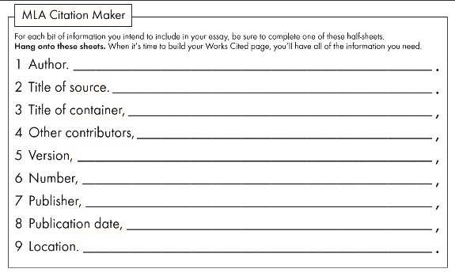
OR
Option 2: Compose notes by source. First, label your sources and
include all information on your MLA Citation maker handout.
Then, aim for at least 10-15 notecards from each source.

Source 1: A Day in the Life of Elvis Presley by Charlie Chaplin.
Then, include all information on your MLA Citation maker handout.
- Make your paraphrase here (in text citation with page number).
- You will then make notecards only from this source (Chaplin 18).
- Remember that your notecards should be paraphrases, NOT direct quotes (Chaplin 19).
- You may, however, use 2-3 direct quotes in your paper, but you do not want your paper riddled with more direct quotes than your own synthesis (Chaplin 19).
- Be sure to visit the OWL Purdue or UNC Chapel Hill websites to read more about how to write research (Chaplin 20).
- Continue all the way down to 10-15 for this source. Then, start with Source 2 until you get to 80 or more notecards.

