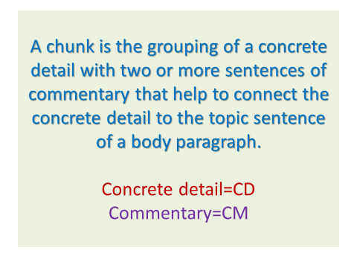

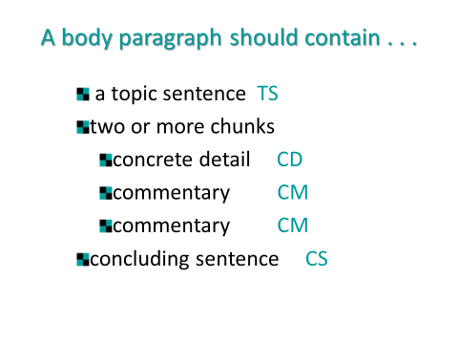

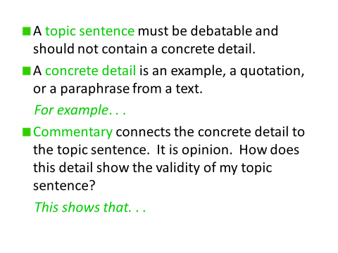

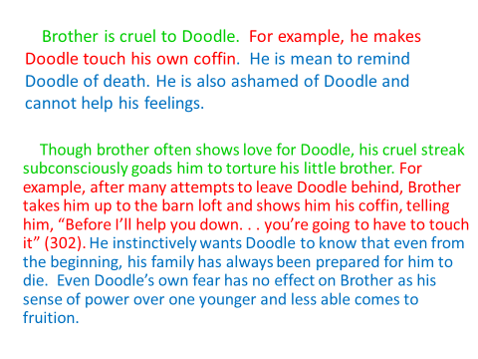

Composing your Hamlet Essay
Paragraph 1: Introduction Paragraph and Thesis Statement- Compose the controlling idea of your paper. Remember that your thesis statement must include the position you will prove and which theme you will discuss. See “Thesis Statement Helps” handout for thesis stems.
Introductory paragraph
Sentence 1: Hook sentence: __________________________________________________________________________ ____________________________________________________________________________________________________________________________________________________________________________________________________
Sentence 2: Bridge Sentence: __________________________________________________________________________ ____________________________________________________________________________________________________________________________________________________________________________________________________
Sentence 3: Thesis Statement: _________________________________________________________________________ _________________________________________________________________________________________________
_________________________________________________________________________________________________ _________________________________________________________________________________________________
Step 2: Mad or Mad in Craft Body Paragraphs - The topic of the first two body paragraphs should be whether Hamlet is “mad” or “mad in craft.” You will prove your claims using evidence from the text.
Do you think Hamlet is mad or mad in craft? _____________________________________________________________
For each paragraph, you will need a topic and conclusion sentence, at least 2 pieces of specific textual evidence that prove your claim (each with a parenthetical citation), and commentary. For each piece of textual evidence, you will provide 1-2 sentences of commentary. Your commentary should answer the question “So What?” Why did you include this piece of evidence? Your commentary will be your explanatory sentence(s)/e.g. the “how” and/or the “why”. Remember that the ratio of commentary to evidence should be at least 2:1, so you should have more commentary than evidence.
Topic sentence for body paragraph 1 (Proving if Hamlet is “mad” or “mad in craft”: ______________________________ ______________________________________________________________________________________________________________________________________________________________________________________________________________________________________________________________________________________________________
Textual evidence #1 (with parenthetical citation): __________________________________________________________ _____________________________________________________________________________________________________________________________________________________________________________________________________________________________________________________________________________________________________
1 to 2 Sentences of Commentary for evidence # 1 (How does this textual evidence prove your claim?): ______________ ________________________________________________________________________________________________________________________________________________________________________________________________________________________________________________________________________________________________________________________________________________________________________________________________________
Textual evidence #2 (with parenthetical citation): __________________________________________________________ _____________________________________________________________________________________________________________________________________________________________________________________________________________________________________________________________________________________________________
1 to 2 Sentences of Commentary for evidence # 2 (How does this textual evidence prove your claim?): ______________ ________________________________________________________________________________________________________________________________________________________________________________________________________________________________________________________________________________________________________________________________________________________________________________________________________
Conclusion sentence for body paragraph 1: ______________________________________________________________ ______________________________________________________________________________________________________________________________________________________________________________________________________________________________________________________________________________________________________
Topic sentence for body paragraph 2 (Proving if Hamlet is “mad” or “mad in craft”: ______________________________ ______________________________________________________________________________________________________________________________________________________________________________________________________________________________________________________________________________________________________
Textual evidence #3 (with parenthetical citation): __________________________________________________________ _____________________________________________________________________________________________________________________________________________________________________________________________________________________________________________________________________________________________________
1 to 2 Sentences of Commentary for evidence # 3 (How does this textual evidence prove your claim?): _______________ _______________________________________________________________________________________________________________________________________________________________________________________________________________________________________________________________________________________________________________________________________________________________________________________________________
Textual evidence #4 (with parenthetical citation): __________________________________________________________ _____________________________________________________________________________________________________________________________________________________________________________________________________________________________________________________________________________________________________
1 to 2 Sentences of Commentary for evidence # 4 (How does this textual evidence prove your claim?): ______________ ________________________________________________________________________________________________________________________________________________________________________________________________________________________________________________________________________________________________________________________________________________________________________________________________________
Conclusion sentence for body paragraph 2: ______________________________________________________________ ______________________________________________________________________________________________________________________________________________________________________________________________________________________________________________________________________________________________________
Step 3: Themes in Hamlet Body paragraph 3- For this body paragraph, you will use the same format as the two paragraphs above, but instead of proving Hamlet’s madness/apparent madness, you will prove how his madness/apparent madness develops a theme.
Theme that I think Hamlet’s madness/apparent madness best helps to develop: __________________________________ ____________________________________________________________________________________________________________________________________________________________________________________________________
Topic sentence for body paragraph 2 (Should include the theme above): _______________________________________ ______________________________________________________________________________________________________________________________________________________________________________________________________________________________________________________________________________________________________
Textual evidence #1 (with parenthetical citation): __________________________________________________________ _____________________________________________________________________________________________________________________________________________________________________________________________________________________________________________________________________________________________________
1 to 2 Sentences of Commentary for evidence # 1 (How does this textual evidence prove your claim?): _______________ _______________________________________________________________________________________________________________________________________________________________________________________________________________________________________________________________________________________________________________________________________________________________________________________________________
Textual evidence #1 (with parenthetical citation): __________________________________________________________ _____________________________________________________________________________________________________________________________________________________________________________________________________________________________________________________________________________________________________
1 to 2 Sentences of Commentary for evidence # 1 (How does this textual evidence prove your claim?): ______________ ________________________________________________________________________________________________________________________________________________________________________________________________________________________________________________________________________________________________________________________________________________________________________________________________________
Conclusion sentence for body paragraph 3: ______________________________________________________________ ______________________________________________________________________________________________________________________________________________________________________________________________________________________________________________________________________________________________________
Step 4: Compose a conclusion paragraph.
Sentence 1: Restatement of the thesis (paraphrased): _______________________________________________________ ____________________________________________________________________________________________________________________________________________________________________________________________________
Sentence 2: Bridge Sentence: _________________________________________________________________________ ____________________________________________________________________________________________________________________________________________________________________________________________________
Sentence 3: So What? Statement: ______________________________________________________________________ ____________________________________________________________________________________________________________________________________________________________________________________________________
Step 5: Put it all together- Type your paper, and add the appropriate transitions for unity and coherence. Be sure to including parenthetically cited textual evidence. Revisit the paper and paragraph outline at the top of this guide. Type your paper in Times New Roman, 12 pt. font (double-spaced).
Step 6: Proofread, proofread, proofread!

