Hamlet Project
Ready, set, action!!! TIME TO GET YOUR DRAMA ON!
Your Task:

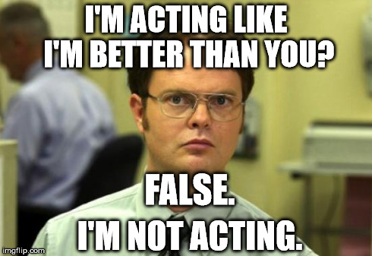
- Below you will find the scenes from Hamlet that YOU get to act out! The scenes differ in number of actors needed, so form your group accordingly. Every person must have a role so, you will need to pick a scene and/or form your group based on the number of actors in the scene. IF you would rather work on this individually, you may choose one of the soliloquies listed below. You will chose scenes on a first-come first-served basis and may sign up on Tuesday, November 21 during third block OR on Monday, November 27. Everyone must chose a scene by the end of third block on Monday, November 27.

- Based off the scene chosen, you and your group now get to act it out. You will be recreating this scene on video, so think about where you will want to film, what costumes you will need to wear, and what props should be included. **Make sure when you are recording the audio is clearly heard and the video quality is clear.

Things to consider:

- If you and your group find a different scene you would like to act out that is not listed below, you must get this approved before leaving for Thanksgiving break.

- Think carefully about who you want to work with. You will need to work outside of class on this, so pick people whose schedule aligns with yours fairly well.

- If you are working alone, you can choose to either video yourself or perform live in class. Whether on video or live, you must still dress accordingly and use at least 1 prop.

- This will count as a mastery grade, so do your best.
Requirements:

- Scene must remain intact and consistent with what is presented in the real Hamlet.
- Every person must have a speaking role.
- Each group must use at least two props (more are encouraged) - costumes do not count as props.
- Every character must be in purposeful costumes (you can modernize them, if you don’t own Shakespearean clothing).
- LINES MUST BE MEMORIZED.
- Scene must be recorded on video and uploaded onto YouTube, brought burned on a CD, or brought on a playable format on a flash drive. We will watch the scenes in class, so your video must be in a playable format.
- Every person must act in character (as best they can). This means saying your lines with the appropriate tone and emphasis, coming into the scene at appropriate times, and speaking on cue.
- If you do not have a phone (or camera or whatever device) to make your video, you need to work with someone who does.

Possible Scenes

One Person
Act 1 Scene 11- Claudius: Lines 1-39
Act 1 Scene 11-Hamlet: Lines 129-159
Act 11 Scene 11-Hamlet: 537-593
Act III Scene 1 – Hamlet: Lines 57-89
Act 111 Scene 2- Hamlet: 53-84

Two People
Act I Scene 5 – Ghost and Prince Hamlet: Ghost revealing his murder
Act III Scene 1 – Hamlet and Ophelia: Breaking up
Act IV Scene 5 – Laertes and Ophelia: Ophelia has gone mad. Make believe flowers. (Could also be used with 3 or 4 people)
Act IV Scene 7 – Laertes and Claudius: Plotting against Hamlet

Three People
Act I Scene 2 – Claudius, Hamlet, and Gertrude: Hamlet’s request to return to France.
Act I Scene 3 – Laertes, Ophelia, and Polonius: Laertes leaving for college, warning Ophelia against falling in love with Hamlet
Act III Scene 4 – Gertrude, Hamlet, and Polonius: Polonius’ murder

Four People
Act I Scene 1 – Barnardo, Francisco, Marcellus, and Horatio standing duty
Act II Scene 2 – Claudius, Gertrude, Polonius, and Hamlet: Polonius spies on Hamlet

Six People
Act V Scene 2 – Osric, Claudius, Hamlet, Laertes, Gertrude, Horatio: The grand finale sword match

Your scene is due on or before: ___________________________________________
Hamlet Project Rubric:
Scene:___________________________________________________________
Group member(s):_______________________________________________ _________________________________________________________________

Acting and Speaking:  -Exemplary effort  -Appropriate tone and diction  -Correct entrances and exits of characters  -Lines delivered clearly  -All lines memorized/no cue cards  -Confidence and poise | _____/20
Creativity  -Purposeful costumes that demonstrate thought and consistence with character  -Purposeful location when filming  -Creative use of literature and skills  -Exhibits time, energy, and genuine effort | _____/30
Accuracy  -A clear understanding of the context of the scene within Hamlet  -Relay clear meaning and importance of the scene and work | _____/30
Following Directions  -Each person in group has a role  -At least 2 props are used (1 if individual) and used purposefully  -Scene is brought or uploaded in a viewable format and on time | _____/10
Video Quality:  -Clear, not shaky  -Loud, clear audio | _____/10
Comments/points for above and beyond: | Total:

