How to Avoid Plagiarism
By the end of high school, you are expected to quote or paraphrase what others have written in your own writing to support your ideas. Use the guide below to support you in using parenthetical citations and creating a works cited page.
Parenthetical Citations
A citation is a quotation from a source. Whenever we use a quotation from an outside source (other than our own brains), we have to acknowledge where we got the information. If we don’t, we are committing plagiarism, which is when we take someone else’s ideas or written text and claim it as our own.
If you take written text directly from another source, you put it in quotations marks. There are times, though, when you might not directly quote someone, but you might still take their ideas and put them into your own words. This is called paraphrasing. If the idea you paraphrase is unique enough, you need to acknowledge where you got the idea or else it can also be considered plagiarism.
Writer use descriptions about where they got their information and place them in parentheses following the quotation or paraphrased ideas. These are called “parenthetical citations” or “in-text citations.”
General rules for using parenthetical citations:
- Within parentheses, include the last name of the author and the specific page numbers of the source (if printed).
“Kids love research” (Smith 2).
- If the author’s name or page number is included in the sentence, then don’t include that in the parentheses.
According to Smith, “Kids love research” (2).
On page 2 of Smith’s essay it says, “Kids love research.”
On page 2 it says, “Kids love research” (Smith).
- If there is more than one author, include the last names. Separate more than two last names with commas.
This is true because “there are many ways to cite authors” (Jones and Washington 13).
“There are many opportunities to do research” (Boudreaux, Brown, and Fontenot 20).
- When citing an online source with no author, use either the article title (in quotation marks) or website title (italicized).
Some think “research is fun” (“Researching Basics”).
Conducting research “takes time and resources” (Educational Tips).

Documenting Sources
List of Sources: In high school students are expected to create a formal bibliography or Works Cited Page using a standard format (e.g., MLA, APA, etc.). As students gather research they should create citations for each of the sources from which they will take notes. A bibliography page should be included with whatever research product is submitted so students understand the importance of documenting from where they got their information and not claiming someone else’s thoughts as their own.

Works Cited Page
A Works Cited page is the place where you list the bibliographic information for the sources you cite in your writing. This will ensure that readers can go locate the source if they are interested in learning more about your writing topic.
General rules for creating a Works Cited page:
- Your Works Cited page should be on its own page at the end of your writing.
- It should be titled Works Cited.
- All entries on the Works Cited page should be double spaced.
- Citations should be listed in alphabetical order.
- The second line of an entry is indented.
- Online citation formatting sites like Citation Machine can format entries.
Sample entries
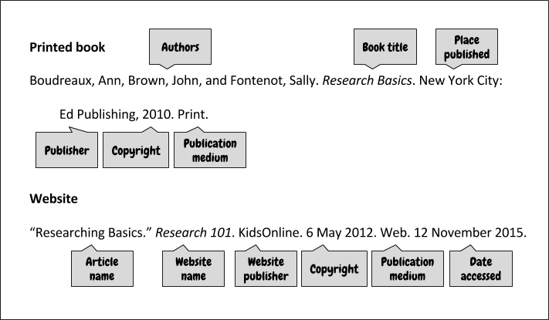
Sample Works Cited Page
