Topic and Conclusion Sentences
You must introduce and conclude each BODY paragraph of your research paper with topic and conclusion sentences.
- A topic sentence will be the first sentence in the paragraph and will introduce the main idea of the body paragraph.
- A conclusion sentence will be the last sentence of the body paragraph and will restate the topic of the paragraph in slightly different words. It can also lead the reader into the next body paragraph. A body paragraph should never end in a parenthetical citation or with textual evidence.

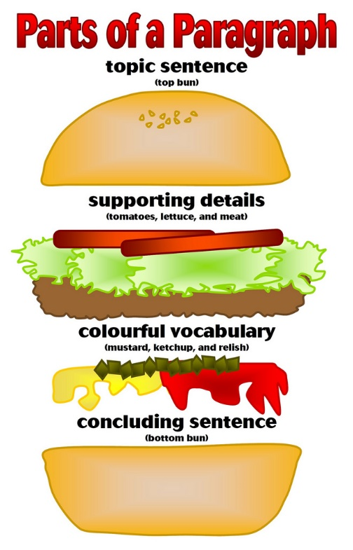
For example:
Topic 1: For many reasons, becoming a coal miner is my career of choice.
Conclusion 1: In conclusion, I would like to become a coal miner because of the working hours and the decent pay.

Topic 2: Over time, my mother did many things to support and care for our family.
Conclusion 2: To summarize, my mother did these things to help her family.

Topic 3: The nature of work of a dentist is intriguing.
Conclusion 3: For all these reasons, it would be very exciting to pursue dentistry.

Topic 4: Several oddities happened in Pollock’s life.
Conclusion 4: Throughout the course of his life, Pollock had many odd happenings.

Topic 5: Mechanics earn a decent living throughout the course of a career.
Conclusion 5: The earnings of a mechanic make the profession worthwhile.
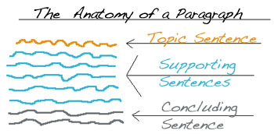

Practice Part I
Underline the topic and conclusion sentences in the following sample paragraph. Then, circle all of the transition words or phrases in the paragraph.

My hometown is famous for several amazing natural features. First, it is noted for the Wheaton River, which is very wide and beautiful. On either side of this river, which is 175 feet wide, are many willow trees which have long branches that can move gracefully in the wind. In autumn the leaves of these trees fall and cover the riverbanks like golden snow. Also, on the other side of the town is Wheaton Hill, which is unusual because it is very steep. Even though it is steep, climbing this hill is not dangerous, because there are some firm rocks along the sides that can be used as stairs. There are no trees around this hill, so it stands clearly against the sky and can be seen from many miles away. The third amazing feature is the Big Old Tree. This tree stands two hundred feet tall and is probably about six hundred years old. These three landmarks are truly amazing and make my hometown a famous place.

Practice Part II
For each of the topic sentences below, underline the words that indicate the subject of the paragraph. Then, compose a conclusion sentence that might be appropriate for that body paragraph. You might have to take some creative license to compose your conclusion sentence.

Topic: Going to college is important for many reasons.
Conclusion: ______________________________________________________________________________ __________________________________________________________________________________________

Topic: The nature of a career in agriculture is interesting.
Conclusion: ______________________________________________________________________________ __________________________________________________________________________________________

Topic: Becoming a T.V. producer takes a lot of hard work.
Conclusion: ______________________________________________________________________________ __________________________________________________________________________________________

Practice Part III
For each of the concluding sentences below, underline the words that indicate the subject of the paragraph. Then, compose a topic sentence that might be appropriate for the body paragraph.

Topic: ___________________________________________________________________________________
_________________________________________________________________________________________
Conclusion: In conclusion, the career as an athletic trainer would be fulfilling.

Topic: ___________________________________________________________________________________
_________________________________________________________________________________________
Conclusion: Overall, the salary of a farmer makes the career worthwhile.

Topic: ___________________________________________________________________________________
_________________________________________________________________________________________
Conclusion: These are the reasons individuals should exercise at least 30 minutes each day.

